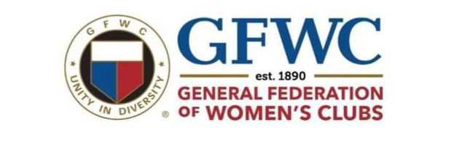
Diamond Bar Woman’s Club
2025 Scholarship Application
$1,000 AWARD

The Diamond Bar Woman’s Club is a service organization. Our members work to make the world a better place through volunteerism and fundraising to support many community projects. To apply for our scholarship, you don’t need to be an “A” student, nor plan to attend a 4-year college. Your autobiography, honors, and activities will weigh heavily in our decision-making process. In past years we have honored students in various areas including academics, art, music, community service, we also offer a medical field award.
Eligibility Requirements:
- Applicants must enroll and attend Fall Quarter/Semester 2025 at a college; (2 or 4 year), Music ( ) Art ( ) Trade School ( ) Certificate Program ( ) or in the Medical Field ( ) – Check all that applies.
- Applicants must be a graduating high school senior from Diamond Bar HS or Diamond Ranch HS, or any of their affiliates with a desire to pursue post-secondary education.
- Homeschooled students may apply (must be a graduating senior who resides in Diamond Bar).
- Applicants must have maintained a cumulative G.P.A. of 2.5 in high school.
- Upon proof of enrollment and attendance, a check will be sent to the student to help defray some of the cost.
- The student will forfeit the award if information not received by: November 1, 2025
- Only completed applications submitted or postmarked by the deadline will be accepted.
Check the school you will graduate from:
- Diamond Bar High School
- Diamond Ranch High School
- Other ____________________________
Please list schools and/or programs you’re applying to:
- _________________________________ 2. __________________________________
3. __________________________________ 4. __________________________________

Please type or print the following information:
Name: ______________________________________ Cell Phone: ___________________________
Address: ____________________________________ City, State, Zip_________________________
You email: __________________________________ Parent’s email: _________________________

Application must be typed and include all of the following:
- Application: completed and signed by applicant and parent/guardian.
- Autobiography (One to two-pages, typed 12 Font) Tell us your personal story, such as:
- An overview that includes the events that have inspired you & helped shape your life, likes/dislikes, situations, and people that have influenced you.
- Tell us your educational/career goals? Why?
Please provide membership in any organization(s) and list any position(s) held or special events in which you participated. For example, (high school activities, community activities, volunteer work, honors, & offices held).
- Transcript: Please upload your official High School Transcript.
- Recommendation: One Letter from your school (i.e., Counselor/Principal/Teacher) and one letter from a community member (i.e., Church/Club/Employer/Coach) who supervised your experience.
- Photography Waiver: Photos will be taken during the Awards Ceremony for publicity. I give permission for my son/daughter to be photographed for use by the Diamond Bar Woman’s Club as related to this scholarship ceremony.
____YES ____NO

Parent Name (print) _______________________ Signature___________________ Date_________

Student Name (print) ______________________Signature____________________ Date_________

Submit your completed application on the Diamond Bar Woman’s Club website:
diamondbarwomansclub.com or
Mail your completed application package to
Diamond Bar Woman’s Club Scholarship Committee
PO Box 4035, Diamond Bar, CA 91765
Completed Application package must be submitted or postmarked by:
DEADLINE: APRIL 11, 2025
Winners will be notified in May and will be expected to attend a Woman’s Club Scholarship Luncheon on Wednesday, May 21, 2025, to be acknowledged.
For further information contact: President Diana Limon: dbwc.volunteers@yahoo.com

